Segregation means keeping things separated, and the Interface Segregation Principle is about separating the interfaces.

The principle states that many client-specific interfaces are better than one general-purpose interface. Clients should not be forced to implement a function they do no need.

Let’s take an example,

Suppose we have an interface called **VehicleChalan**

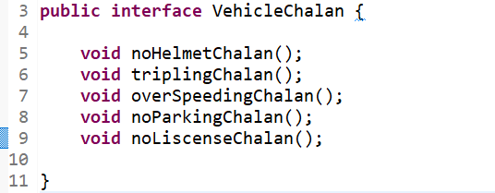

Now, we have a class **BikeChalan** which is implementing **VehicleChalan**

As you can see that whatever method coming from the **VehicleChalan** interface is going to be use in **BikeChalan**. Because whatever chalan is mentioned in **VehicleChalan** interface is belong to bike.

But if some other class i.e. **CarChalan** is implements the **VehicleChalan**

Car do not have Helmet Chalan and Tripling Chalan restrictions, so this two method should not be there in this class. But if this **CarChalan** class implements **VehicleChalan** then unwillingly it has to override the **noHelmetChalan()** and **triplingChalan()** methods too.

And by doing this, a developer will be break the **ISP.**

**Instead what should be do ?**

We should segregate the **VehicleChalan** interface into two some other interfaces.

We will create two different interfaces i.e. **TwoWheelerChalan** and **FourWheelerChalan**

Now, **Car** class should extends **FourWheelerChalan** and **Bike** class should extends **TwoWheelerChalan**

Now we are following **Interface Segregation Principle**